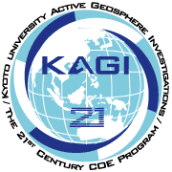
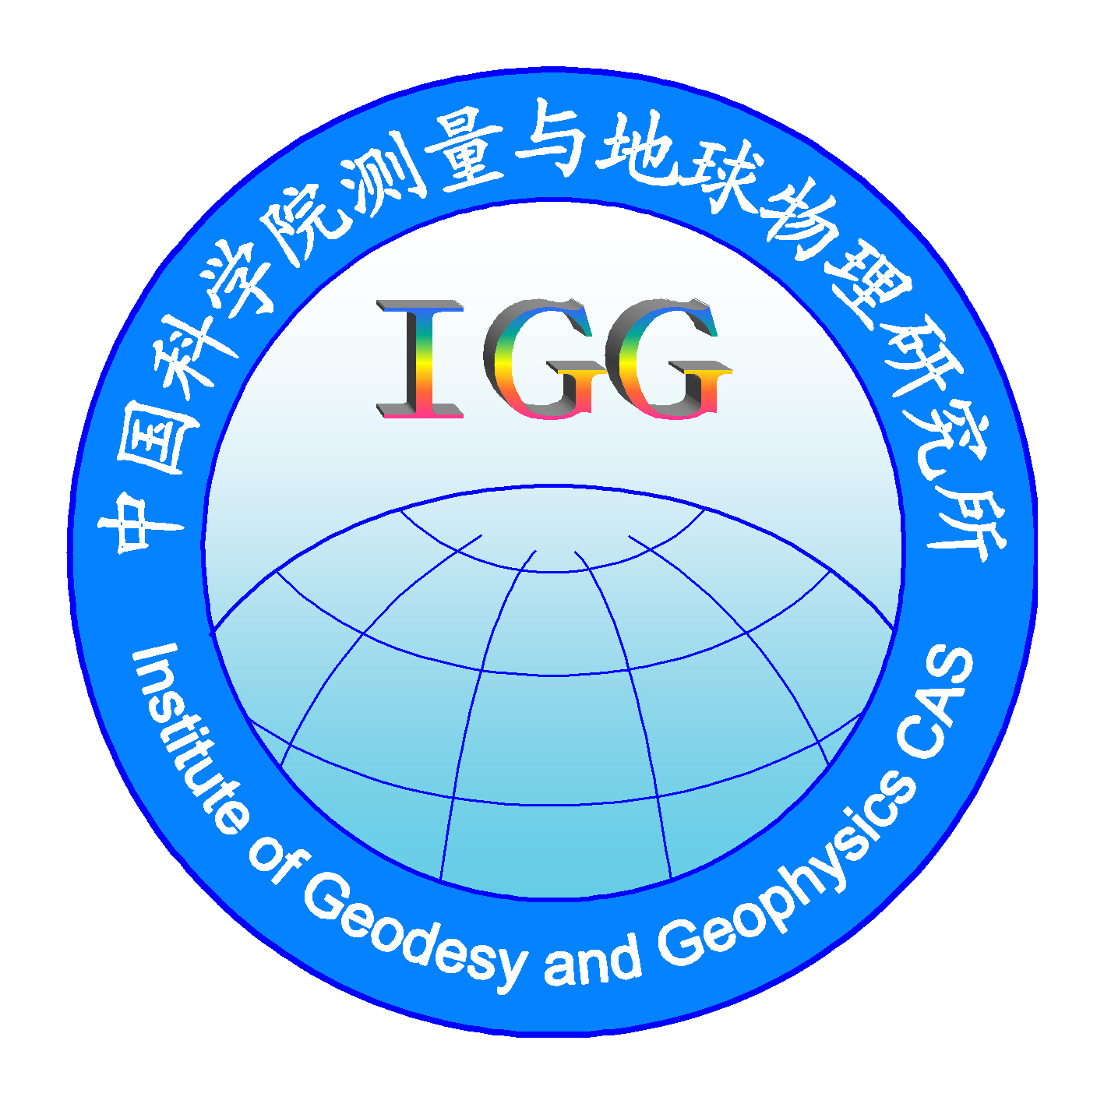
地球圈层活动研究
国际学术讨论会
3P^{rdP} KAGI21 International Symposium
（November 8-10, 2005）
Web address in China Web address in Japan
HTUhttp://www.whigg.ac.cn/AGI2005Wuhan/index.htmlUTH; HTUhttp://kagi.coe21.kyoto-u.ac.jp/en/index.htmlUTH
Second Circular（第二号通知）
Organized by | 主办单位
Institute of Geodesy and Geophysics,  Chinese Academy of Sciences, China  KAGI21 Office, Graduate School of Science, Kyoto University, Japan | 中国科学院测量与地球物理研究所  日本京都大学KAGI21项目办公室
Sponsored by | 赞助单位
Chinese Academy of Sciences, China  Nature Science Foundation of China | 中国科学院，  中国国家自然科学基金委
Co-organized by | 合办单位
Wuhan University  China University of Geosciences  Institute of Seismology, Chinese Earthquake Administration | 武汉大学  中国地质大学  中国地震局地震研究所
Submission of Abstract and Paper | 提交会议文章方式
To: Conveners of Topics | 直接提交给：会议专题负责人
Contacts（meeting secretary） | 联系方式（会议秘书）
Chinese side:  Mr. Cheng-Shu LIU  Institute of Geodesy and Geophysics  Chinese Academy of Sciences  Email: HTUsywc@asch.whigg.ac.cnUTH  Tell/Fax: +86-27-68881362  Japanese Side:  Ms. KIOKA, Miki  KAGI 21 Secretary  Graduate School of Science  Kyoto University  Email: HTUmkioka@kugi.kyoto-u.ac.jpUTH  Tel/Fax is +81-75-7534299 | U中国方面：  刘成恕先生  中国科学院测量与地球物理研究所  Email: HTUsywc@asch.whigg.ac.cnUTH  Tell/Fax: +86-27-68881362  U日本方面:  Ms. KIOKA, Miki  KAGI 21 Secretary  Graduate School of Science  Kyoto University  Email: HTUmkioka@kugi.kyoto-u.ac.jpUTH  Tel/Fax is +81-75-7534299
U
DATE AND LOCATION （会议地点和位置）
November 8-10, 2005 in the Institute of Geodesy and Geophysics, Chinese Academy of Sciences, Wuhan, China
UGENERAL DESCRIPTION OF THE SYMPOSIUM（会议内容概述）
The “International Symposium on the Active Geosphere Investigation”, together with the 3rd KAGI21 (Kyoto university Active Geosphere Investigations for the 21st century COE program) International Symposium, will be held during the period from November 8 to 10, 2005 in Wuhan, China. This symposium is co-organized by the Institute of Geodesy and Geophysics, Chinese Academy of Sciences and Kyoto University Active Geosphere Investigations for the 21st century COE program (KAGI21) Office.
The symposium will cover a new multi-disciplinary approach for the Earth sciences that emphasizes the physical processes in encompassing of the "Active Geospheres". In this framework, we will provide for scientists the chance of the exchange and discussion along the world in an integrated study of the processes that take place throughout many realms of the Earth’s science.
As the rapid progress in study of the Earth’s lithosphere, tectonics in the shallow Earth’s crust, general circulations of oceans and the atmosphere, and multi-timescale variations of the climate system, the common threads that link these processes include the energy flows that couple all portions of the Geosphere. Since such phenomena evolve and interact on a variety of space and time scales, a new interdisciplinary approach based on optimal inter-related areas of the Earth sciences and recent advances in observational and computational technologies is required.
The symposium sets traditional fields of the Earth sciences, such as Space Physics, Aeronomy, Atmospheric and Oceanic Sciences, Seismology, Volcanology, Geodesy, Geology, and Material Science for the Earth, as the primary ingredients, and then creates a melting pot of Field Survey/Observations, Satellite Measurements, Data Analyses, and Laboratory and Numerical Experiments, that encourage cross-disciplinary studies. This approach is central to our interpretation of the Active Geosphere and, in a wider sense, to the sustainable coexistence of human beings on the Earth. The challenge is to improve our understanding of the complex processes within the Active Geosphere and obtain new perspectives on the individual components.
The symposium will cover various topics given as (1) Continental collisions in the past and present, (2) Seismotectonics, (3) Geodetic observations, (4) Climate Changes in the past and present, (5) Monsoon Variability and the Tibetan Plateau (6) Geospace and Atmosphere.

USCIENTIFIC COMMITTEE（科学委员会）
Honorary Chairperson（荣誉主席）
Prof. Li JY（李家洋）：Prof., and Vice President, Chinese Academy of Sciences, Beijing, China
Chairpersons（主席）
Hsu H T（许厚泽）：Prof., Institute of Geodesy and Geophysics, Chinese Academy of Sciences, Wuhan, China (Email: hsuh@asch.whigg.ac.cn)
Yoden S：Prof., Department of Geophysics, Graduate School of Science, Kyoto University, Kyoto, Japan (Email: yoden@kugi.Kyoto-u.ac.jp)
Members （成员）
Chao B（赵丰）：Prof., Space Geodesy Branch, NASA Goddard Space Flight Center，USA
Chen JY（陈俊勇）：Prof., State Bureau of Surveying and Mapping, Beijing, China
Chen YT（陈运泰）：Prof., Institute of Geophysics, State Seismology Bureau, Beijing, China
Dehant V：Prof., Royal Observatory of Belgium, Brussels, Belgium
Fan WM（范蔚民）：Prof., Chinese Academy of Sciences, Beijing, China
Hirajima T：Prof., Department of Geophysics, Graduate School of Science, Kyoto University, Japan
Huang C（黄王成）：Prof., Shanghai Astronomical Observatory, Chinese Academy of Science, Shanghai, China
Liu JN（刘经南）：Prof., President, Wuhan University, Wuhan, China
Liu ZX （刘振兴）：Prof., Center for Space Science and Applied Research, Chinese Academy of Sciences, Beijing, China
Mori J：Prof., Disaster Prevention Research Institute, Kyoto University, Japan
Phillander G：Prof., Department of Geosciences, Princeton University, USA
Shi YL（石耀霖）：Prof., Graduate Institute, Chinese Academy of Sciences, Beijing, China
Takemoto S：Prof., Dep. of Geophysics, Graduate School of Science, Kyoto University, Japan
Tapponnier P：Prof., Institut de Physique du Globe, Paris, France
Tsuda T：Prof., GPS/Atmosphere, Research Institute for Sustainable, Humanosphere, Kyoto University, Japan
Vincent R：Prof., Adelaide University, Australia
Wang B（王斌）：Prof., School of Ocean & Earth Science & Technology, University of Hawaii, USA
Wang WJ（王会军）：Prof., Institute of Atmospheric Physics, Chinese Academy of Sciences, Beijing, China
Xiao Z（肖佐）：Prof., Beijing University, Beijing, China
Yu C（于晟）：Prof., Geophysics and Space Sciences, National Nature Science Foundation, Beijing, China
Zhu YZ（朱耀仲）：Prof., Institute of Geodesy and Geophysics, Chinese Academy of Sciences, Wuhan, China

ULOCAL ORGANIZING COMMITTEE（地方组织委员会）
Chairperson（主席）
Sun HP（孙和平）：Prof., Institute of Geodesy and Geophysics, Chinese Academy of Sciences，China
Fukuda Y：Dr., Department of Geophysics, Graduate School of Science, Kyoto University, Japan
Members （成员）
Chen C（陈 超）：Prof., Institute of Geophysics and Geomatics, China University of Geosciences, Wuhan, China
Deng X H（邓晓华）：Prof., Wuhan University, Wuhan, China
Li JC（李建成）：Prof., Institute Surveying and Mapping, Wuhan University, Wuhan, China
Wang Y（王勇）：Prof., Institute of Geodesy and Geophysics, Chinese Academy of Sciences, Wuhan, China
Wu Y（吴云）：Prof., Institute of Seismology, China Seismological Bureau, Wuhan, China
Xu PL（徐培良）：Dr., Institute of Disaster Prevention, Kyoto University, Japan
Zhu J（朱江）：Prof., Institute of Atmospheric Physics, Chinese Academy of Sciences, Beijing, China

MAIN SESSIONS AND CONVENERS （会议主题）U
General Topic：Global Interactions of the Active Geospheres
Conveners：Takemoto S（Email：HTUtakemoto@kugi.kyoto-u.ac.jpUTH）
Hsu H Z（许厚泽，HTUhsuh@asch.whigg.ac.cnUTH）
Contents： General reports on the Active Geospheres Investigations
Topic 1： Continental Collisions in the Past and Present
Conveners：Hirajima T（E-mail: HTUhirajima@kueps.kyoto-u.ac.jpUTH）
Zhang PZ（张培震, Email: HTUpeizhen@gps.gov.cnUTH）
Contents： Qinghai-Tibet plateau, Crustal Movement
Topic 2： Seismotectonics
Conveners：Mori J (Email：HTUmori@rcep.dpri.kyoto-u.ac.jpUTH)
Wu Y（吴云, Email：HTUwuyun@public.wh.hb.cnUTH）
Contents： Geological and Seismological Distribution
Topic 3：Geodetic Observations
Conveners：Fukuda Y（Email: HTUfukuda@kugi.kyoto-u.ac.jpUTH）
Wang Y (王勇, Email: HTUywang@asch.whigg.ac.cnUTH)
Contents： GPS and Gravity
Topic 4： Climate Change in the Past and Present
Conveners：Takemura K（Email：HTUtakemura@bep.vgs.kyoto-u.ac.jpUTH），
Ding ZL（丁仲礼, Email：HTUzlding@mail.igcas.ac.cnUTH）
Contents：Geology and Geomorphology
Topic 5： Monsoon Variability and the Tibetan Plateau
Conveners：Satomura T（HTUsatomura@kugi.kyoto-u.ac.jpUTH）
Zhu J (朱江, Email：HTUjzhu@mail.iap.ac.cnUTH)
Contents： Meteorology, Climatology, Oceanography
Topic 6： Geospace and Atmosphere
Conveners：Omura Y（Email：HTUomura@rish.kyoto-u.ac.jpUTH）
Deng X H (邓晓华, Email：HTUdengxh@public.wh.hb.cnUTH)
Contents： Ground and satellite observations, Space environment of the Earth
U
MEETING LANGUAGE（会议语言）
English is the official language of the symposium.

CALL FOR PAPERS（会议征文）
Abstract should be submitted to both the conveners of topics and meeting secretaries before the deadline of September 20, 2005, by Email submission. The paper, which will be included in the Proceedings without review, should be submitted before February 10, 2006. The cost of the proceedings is included in the registration fee. For the format of abstract and paper, please refer Instruction for Contributions.

Instruction for Contributions
Format of abstract
An abstract of less than 500 words followed by up to five key words should be submitted to the convener of special topic. The abstract should be condensed to one A4 page. The abstract must be intelligible without reference; It should be a condensation of the essential information of research. Abstract should be arranged in single spacing, and should be processed by Microsoft Word. All margins should be at least 2.5 cm wide. Abstract should be typeset by authors following the standard format as illustrated below.

Title(Font-Times New Roman 16p, Black, PB(Paragraph Before 30p)

Name of Authors ( Arail-12p, PB 12p)
Address (Times New Roman 9p, PB 6p)
Text (Times New Roman-10.5p)
Keywords: Keywords (Times New Roman-10.5p,Black,PB6p), content (Times New Roman, black, 10.5p)

Papers Format:
1. Manuscript should be arranged in single spacing of A4 paper, and should be processed by Microsoft Word. All margins should be at least 2.5 cm wide. The standard order of a manuscript is: title, authors, authors’ addresses, abstract, keywords, text, acknowledgments, references, and appendices. Manuscript should be typeset by authors following the standard format as illustrated below. All tables, figures, and figure captions should be inserted in the text at their appropriate positions.
2. Abstract is required to be less than 300 words followed by up to five key words.
3. To improve the readability of papers, authors may use up to three levels of headings:
4. References should be listed in alphabetical order, as in the following examples:
Journal Article:
Kenner, S. J. and Segall, P., 2000. Postseismic deformation following the 1906 San Francisco earthquake, J. Geophys. Res., 105, 13 195-13 209.
Book:
Ernst, W.G., 1976, Petrologic Phase Equilibria. Freeman, San Francisco, 333 p.
Book Article:
Wang, X., Zhang, R. and Liou, J.G., 1995, UHPM terrane in east central China. In: Coleman, R.G. and Wang, X. (eds.), Ultrahigh Pressure Metamorphism. Cambridge University Press, Cambridge, p. 356.
Abstract:
Lefeuvre, F., 1994, Fracture related anisotropy detection and analysis: if the P-waves were enough. 64th Annual International Meeting of Society of Exploration and Geophysics (Expanded Abstract), Los Angeles, Oct. 2003, p. 942.
Thesis:
Sobouti, F., 2000, Thermo-mechanical Modeling of Subduction of Continental Lithosphere, McGill University, Montreal, 120 p.
Report:
Choi, H.S., Kim, M.H., Chun, I.K., Kim, S.Y., Lee, E.K. and Park, Y.M., 1995, Fossil Floral and Faunal Assemblage and Paleoenvironmental Modelling Study on the Cretaceous Sedimentary Basins Scattered in/near the Okchon Belt (I). Report KR-95(T)-9, Korea Institute of Geology, Mining and Materials, Taejon, 85 p.

5. The SI unit should be used wherever possible.
6. Maximum number of pages per paper is 10, including all figures, tables and references.

Title(Font-Times New Roman 16p, Black, PB (Paragraph Before 30p)

Name of Authors ( Arail-12p, PB 12p)
Address (Times New Roman 9p, PB 6p)
Abstract : Abstract (Times New Roman-10.5p, Black, PB6p), content (Times New Roman -10.5p).

Keywords: Keywords (Times New Roman-10.5p, Black, PB6p), content (Times New Roman-10.5p)

1st order Subtitle (Times New Roman-10.5p, in CAPITAL, Black, PB18p, with labeled order)
2nd order Subtitle(Times New Roman-10.5p, BLACK, with labeled order)
3rd order Subtitle(Times New Roman-10.5p, BLACK, with labeled order)
Text (Times New Roman-10.5p)
Acknowledgements: Acknowledgements (Times New Roman-9p, Black, PB10p), content (Times New Roman, 9p)
References (Times New Roman-10.5p, Black, PB10p)
List of reference (Times New Roman-10p)

POST-MEETING EXCURSION（可选：会后地质考察）U
Option 1: One day tour in Wuhan city
Wuhan, with an area of 8467 sq km and a population of 7.28 million, is the capital of Hubei province, and one of the major economic and industrial cities in China. Located in the very center of China, where the Yangtze River, the third biggest in the world meets its biggest tributary the Han River, Wuhan is divided by the two rivers into 3 towns, named Hankou, Hanyang and Wuchang, each the size of a small city in itself. Being accessible by water and land, it has earned the reputation of "the thoroughfare to nine provinces" and functions as one of the few pivots of water, land, air, post and telecommunication.
Wuhan is an important domestic and foreign commercial port and the center of industry, finance, commerce, science and education for central China. With the development of the Yangtze Valley, Wuhan is becoming increasingly important both in domestic and international terms, specifically as an important education and scientific research base, due largely to the sizeable university and student population.
There are many scenic spots and historical sites to visit in Wuhan, the "Homeland of White Clouds and Yellow Crane", including the Yellow Crane Tower with the 1,700 years history, one of the three famous towers in South China, the East Lake whose natural beauty rivals that of the West Lake in Hangzhou, the ancient Guiyuan Temple, and the European-style buildings remained along the Yanjiang Street, as well as the modern International Amusement Park.

Option 2: Three days tour to three gorges (via travel agency)
The Three Gorges, the most spectacular section of the Yangtze River, are filled with breathtaking sceneries. With Baidi City to the west end and Yichang in the Hubei province at the east, the Three Gorges, Qutang, Wu and Xiling, total 192 km in length. The Qutang Gorge, known for its magnificence, is only 8 km long. Wu Gorge, 44 km long, is famed for its deep valley and quiet beauty. Among the twelve peaks, the Goddess Peak is the most exquisite. Xiling Gorge, extending 66 km in length and full of turbulent currents and whirlpools, is one of the most dangerous shoals.
Along the Three Gorges, there are broad valleys, where the climate is mild and the soil fertile. These valleys are the main cultivated areas in the Three Gorges, where the county towns of Wushan, Badong and Zigui are located. In the autumn when the orange ripens, its sweet fragrance drifts to the boats on the river.
Cost: $260 for 3 days
Please visit the website http://www.yc.chinanews.com.cn/sxly/tsjg.htm for details.

Option 3: Three days tour to Lushan Mt. area (via travel agency)
Lushan Mountain，situated in the north of Jiangxi Province, occupies an area of 302 square kilometers.
The mountain boasts in its mighty peaks, roaring waterfalls, mysterious clouds and mists, an ancient academy, and many western-styled villas. It was among the first Key Scenic Districts of China, and was one of the districts best owed the titles of "Forty Best Scenic Districts of China", “National Exemplary Scenic and Historic Interest District", "National Geopark of China", "AAAA-rated Tourism District" and so on.

With its peculiar style in historic remains, which is melted with remarkable natural beauty, Mt Lushan has formed a highly aesthetically-valued cultural view closely relevant to the sprit of the Chinese people and their cultural life
United Nations Educational Scientific and Cultural Organization, UNESCO
December 6,1996

Cost: $130 for 3 days
(please visit the website http://www.jiujiang.gov.cn/jjlyw/lushan/ziran/ for details)

Access to Wuhan（到达）
Wuhan, one of the beautiful cities in China, is located in the central part of China, which can be accessed easily by air and train.
1. Arrival by Air
Tian-He Airport, serving Wuhan, can be accessed directly from several locations overseas, including Fukuoka (Japan), Seoul (Korea), and many domestic cities, including, Hong Kong, Beijing, Shanghai, Guangzhou, Shenzhen, etc.
A taxi ride from Tianhe Airport to Liyuan Hotel takes about one hour. The fare is about $12.

2. Arrival by Train
Wuhan is one of the most important pivot of railway transportation in China, which is easily accessed directly from domestic major cities.
Taxi rides from Wuchang and Hankou Railway Stations take about twenty and forty minutes, with fares about $3 and $5, respectively.

UACCOMMODATIONS（食宿安排）
Liyuan Hotel (3 Star hotel)
Liyuan, a comfortable and well-located hotel, is close to and East Lake, Museum of Hubei Province which is well-known by exhibition of ancient music instrument, the meeting venue, as well as several shopping centers and department stores. Enticing rooms, spacious suites, stylish facilities, delicious traditional Chinese food, and enthusiastic committed staff make your stay at Liyuan Hotel truly memorable. For detailed information, please visit the website HTUhttp://www.lyhotel.com/UT.

U
REGISTRATION（注册）
Registration fee: 500 Chinese Yuan

In order to facilitate our arrangement for your hotel reservation, please fill in the Register Return Receipt, and send back to us as soon as possible.

Registration Form of the 3rd KAGI21 International Symposium, Wuhan
Name： | Institution：
Title（please check “√” in correlative column）
Professor Associate professor PhD Master
Phone Number： |  | Email Address：
Topic of your paper：
Room choice: single（380CNY）； Double I（260 CNY）； Double II（320CNY）
No. of persons ( ) % All the rates are per person, including breakfast.
Dates of Arrival and leaving
Post-meeting Excursion: Yes Option 1； Option 2； Option 3
No
Please send the return receipt to:
Institute of Geodesy and Geophysics, Chinese Academy of Sciences
340 Xudong Street, Wuhan, Hubei 430077, P. R. China
Mr. Chengshu Liu
Fax/Tel：86-27-68881362
Email: sywc@asch.whigg.ac.cn
Please download the Registration Form from website also. If you have more questions, you can contact：Mr. Chengshu Liu：sywc@asch.whigg.ac.cn or
Prof. Heping Sun：heping@asch.whigg.ac.cn

